**BỘ GIÁO DỤC & ĐÀO TẠO**

**TRƯỜNG ĐẠI HỌC SƯ PHẠM KỸ THUẬT TP. HỒ CHÍ MINH**

**KHOA CHẤT LƯỢNG CAO**

**BỘ MÔN TỰ ĐỘNG ĐIỀU KHIỂN**

**-----------------⸙∆⸙-----------------**



**WEEKLY REPORT**

**Topic: APPLICATION OF MATLAB IN SURVEYING STABILIZATION OF A SYSTEM**

**GVHD: Trần Đức Thiện**

**SVTH: Trần Minh Quân**

**MSSV: 19151078**

**Tp. Hồ Chí Minh ngày 28 tháng 02 năm 2022**

Contents

1. Surveying a system using Bode’s diagram 4

1.1 Requirement 4

1.2 Solution 4

1.2.1 With K=10, plot a magnitude and phase bode diagram of the above system with frequency in a range of (0.1, 100). 4

1.2.2 With K=10, plot a magnitude and phase bode diagram of the above system with frequency in a range of (0.1, 100). 6

2. Surveying the system using Nyquist’s diagram 7

2.1 Requirement 7

2.2 Solution 7

2.2.1 K=10 7

2.2.2 K=400 8

3. Surveying the system using root locus 9

3.1 Requirement 9

3.2 Solution: 9

3.2.1 Kgh is the point where the graph and the imaginary axis intersect. 9

3.2.2 Gain K when ωn = 4: 10

3.2.3 Gain K when damping = 0.701 10

3.2.4 Gain K when σmax% = 25% 11

3.2.5 Gain K when txl =4s 11

4. Exercise 12

4.1 Requirement 12

4.2 Solution 12

4.2.1 Root locus graph of the system and find Kgh. 12

4.2.2 Gain K when ωn = 4: 13

4.2.3 Gain K when damping ξ = 0.7 13

4.2.4 Gain K when overshoot σmax% = 25% 14

4.2.5 Gain K when txl =4s 14

4.2.6 Bode diagram of the system with 15

4.2.7 Nyquist diagram of the system with 15

5. Open question 16

Figure 1: Bode diagram of a system with K=10 4

Figure 2: Step response of the system with K=10 5

Figure 3: Bode diagram of the system with K=400 6

Figure 4: Step response of a system with K=400 7

Figure 5: Nyquist diagram with K=10 8

Figure 6: : Nyquist diagram with K=400 8

Figure 7: Root locus graph at gain K=164 9

Figure 8: Root locus graph at ωn = 4 10

Figure 9: Root locus graph at ξ = 0.7 10

Figure 10: Root locus with σmax% = 25% 11

Figure 11: Root locus with txl =4s 11

Figure 12: Root locus graph of the system with 12

Figure 13: Root locus graph at ωn = 4 13

Figure 14: Root locus graph at σmax% = 25% 14

Figure 15: Root locus graph at txl = 4s 14

Figure 16: Bode diagram of the system with K=57 15

Figure 17: Nyquist diagram with K=57 15

# Surveying a system using Bode’s diagram

## Requirement

|  |  |
| --- | --- |
|  | (1.1) |

With K=10

a. Plot a magnitude and phase bode diagram of the above system with frequency in a range of (0.1, 100).

b. Used the bode diagram to find the gain margin, phase margin and the frequency.

c. Comment about the stability of the system

d. Draw the step response with input is a unit step function with t from (0:10)s to illustrate your conclusion in answer c.

e. Repeat a,b,c,d with K = 400.

## Solution

### With K=10, plot a magnitude and phase bode diagram of the above system with frequency in a range of (0.1, 100).

**Bode diagram of the system**:

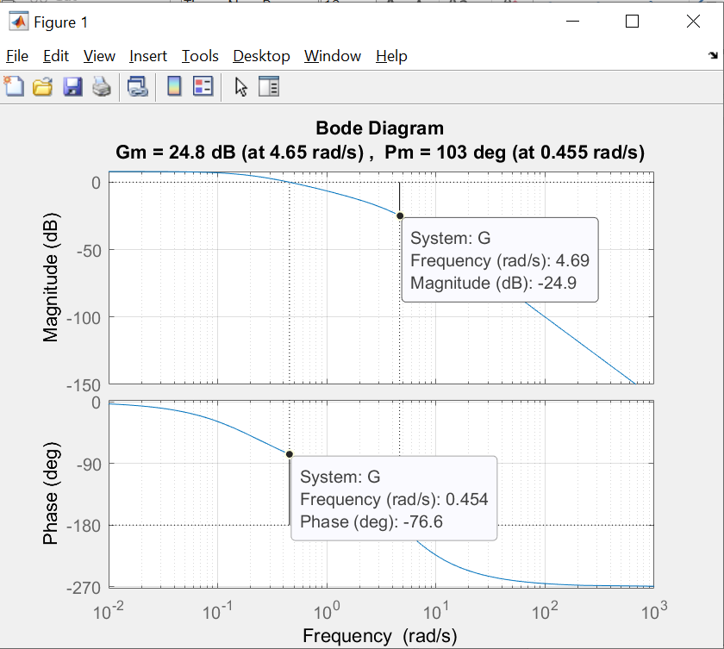

Figure 1: Bode diagram of a system with K=10

From the bode diagram, we know that

* Phase margin: 103 deg
* Gain margin: 24.8 Db
* Frequency of phase margin: 4.69 rad/s
* Frequency of gain margin: 0.454 rad/s
* Because of the phase margin and gain margin are both greater than 0 so the system is stable.

**Step response of a system:**

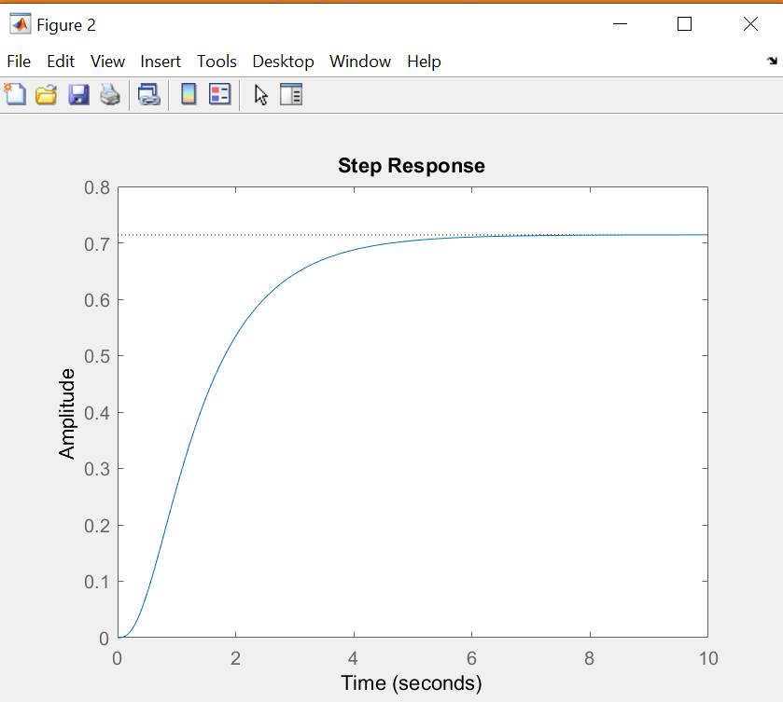

Figure 2: Step response of the system with K=10

### With K=10, plot a magnitude and phase bode diagram of the above system with frequency in a range of (0.1, 100).

**Bode diagram of the system:**

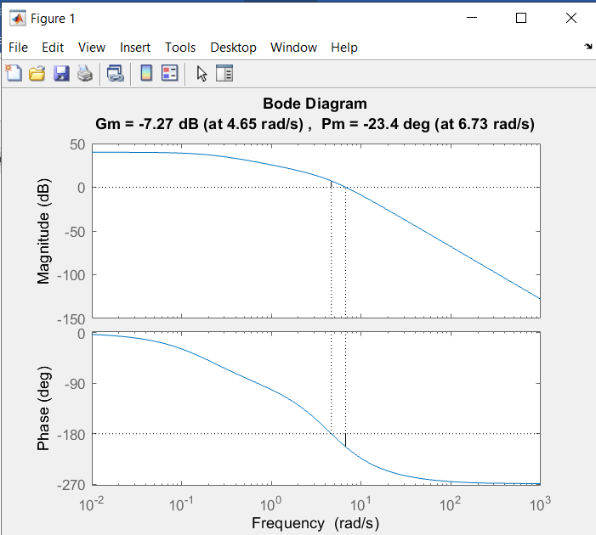

Figure 3: Bode diagram of the system with K=400

From the bode diagram, we know that

* Phase margin: -23.4 deg
* Gain margin: -7.27 Db
* Frequency of phase margin: 6.73 rad/s
* Frequency of gain margin: 4.65 rad/s
* Because of the phase margin and gain margin are both less than 0 so the system is not stable.

**Step response of the system**:

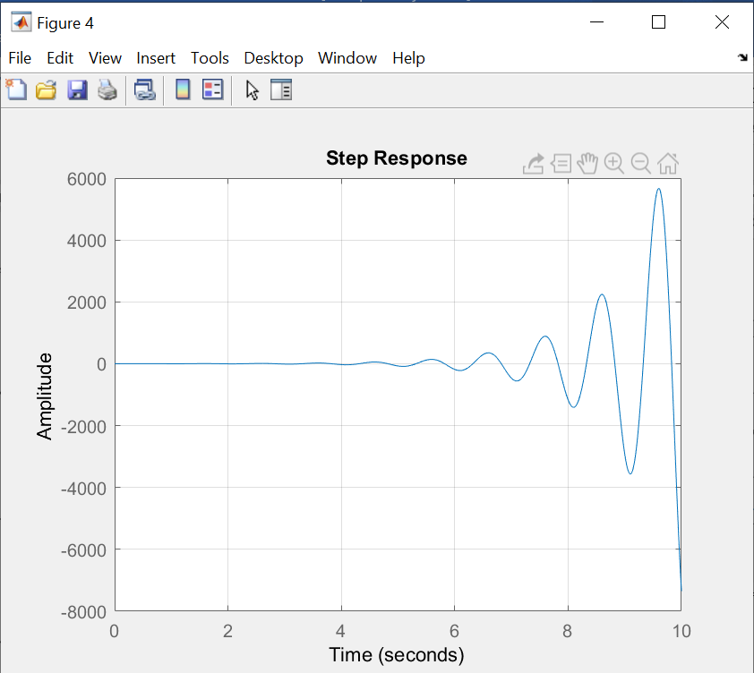

Figure 4: Step response of a system with K=400

# Surveying the system using Nyquist’s diagram

## Requirement

|  |  |
| --- | --- |
|  | (1.2) |

a. With K=10, plot the nyquist diagram of the above system.  
b. Used the nyquist diagram to find the phase margin and gain margin. Compare the result with the bode diagram above.

c. Comment about the system stability, explain

d. With K=400, repeat the process from a→c

## Solution

### K=10

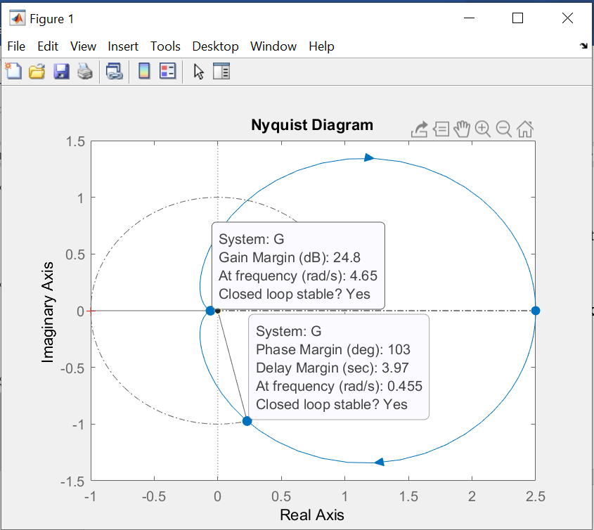

Figure 5: Nyquist diagram with K=10

Phase margin: 103 deg

Gain margin: 24.8 Db

* The Nyquist diagram and Bode diagram give the same result about the phase margin and gain margin.

Because the diagran does not include the point (-1+j0) and it also a close loop system so this system is stable.

### K=400

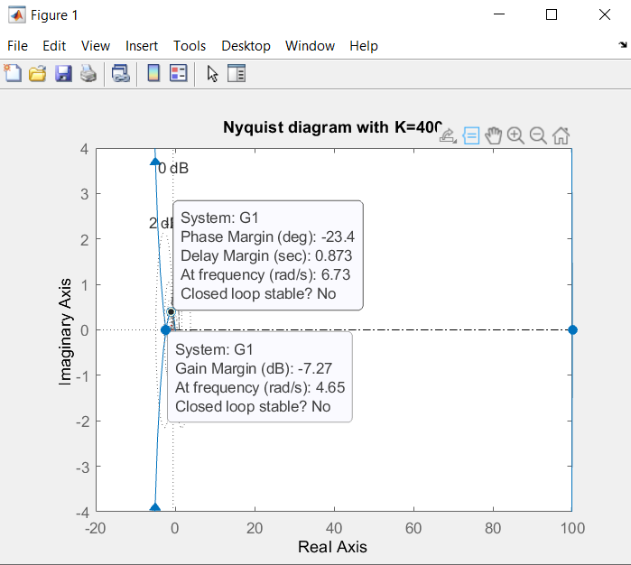

Figure 6: : Nyquist diagram with K=400

Phase margin: -23.4 deg

Gain margin: -7.27 dB

* The Nyquist diagram and Bode diagram give the same result about the phase margin and gain margin.

Because the diagran does include the point (-1+j0) and it also a close loop system so this system is stable.

# Surveying the system using root locus

## Requirement

|  |  |
| --- | --- |
|  | (1.3) |

a. Plot the root locus graph of the system. From the graph find the limit of gain Kgh.  
b. Find K so that ωn = 4  
c. Find K so that damping ξ = 0.7  
d. Find K so that overshoot σmax% = 25%  
e. Find K so that settling time (e = 2%) txl = 4s

## Solution:

### Kgh is the point where the graph and the imaginary axis intersect.

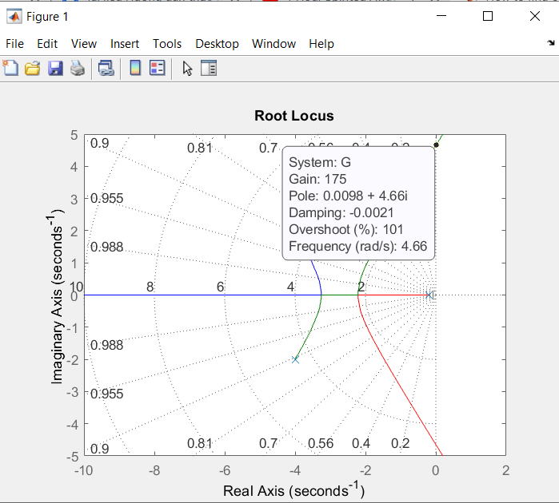

Figure 7: Root locus graph at gain K=175

### Gain K when ωn = 4:

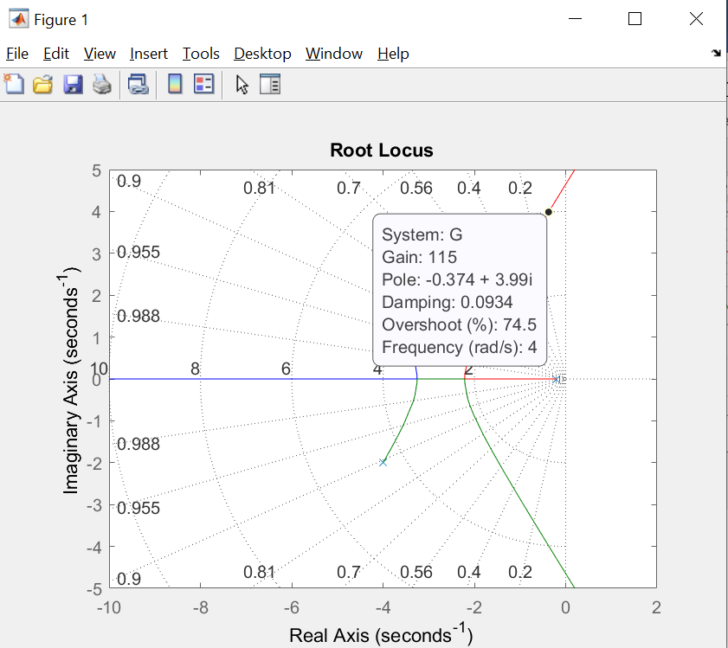

Figure 8: Root locus graph at ωn = 4

* K=115

### Gain K when damping = 0.701

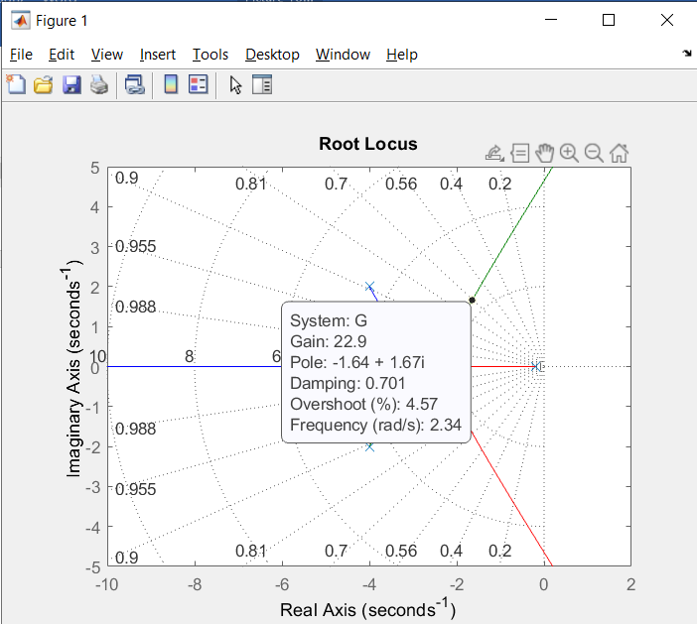

Figure 9: Root locus graph at ξ = 0.7

* K=22.9

### Gain K when σmax% = 25%

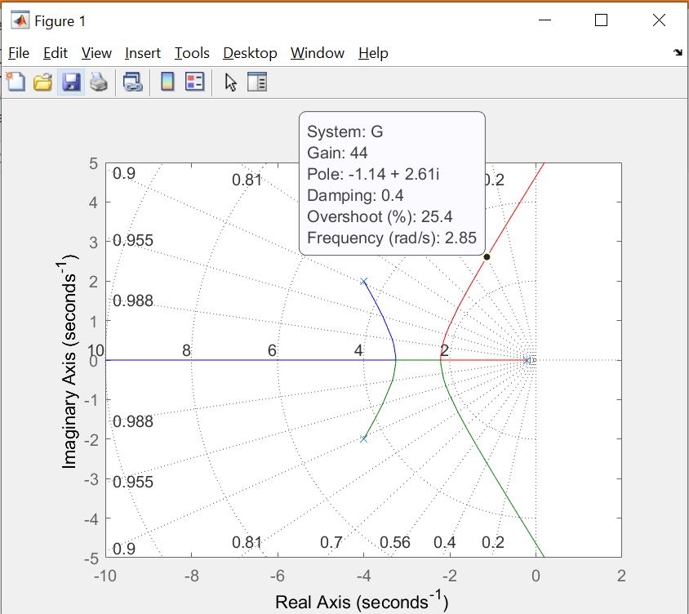

Figure 10: Root locus with σmax% = 25%

* K=44

### Gain K when txl =4s

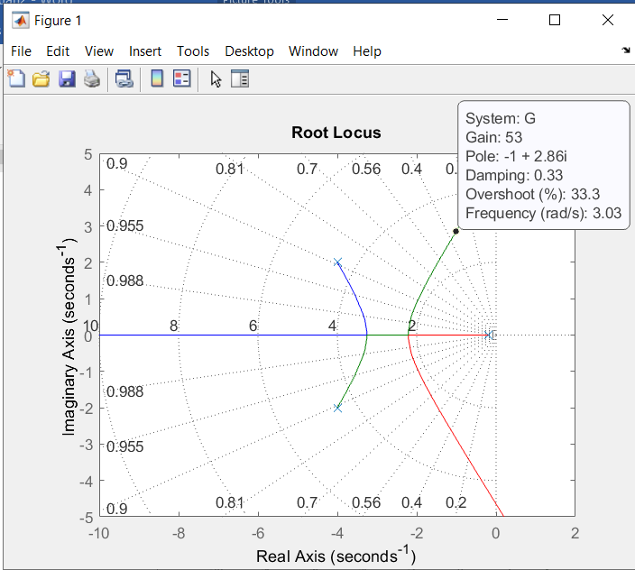

Figure 11: Root locus with txl =4s

* K = 53

# Exercise

## Requirement

|  |  |
| --- | --- |
|  | (1.4) |

1. Plot the root locus of the system. From the graph find the limit of gain Kgh.
2. Find K so that ωn = 4.
3. Find K so that damping ξ = 0.7.
4. Find K so that overshoot σmax% = 25%.
5. Find K so that settling time (e = 2%) txl = 4s.
6. Plot the Bode diagram and Nyquist diagram with gain .

## Solution

### Root locus graph of the system and find Kgh.

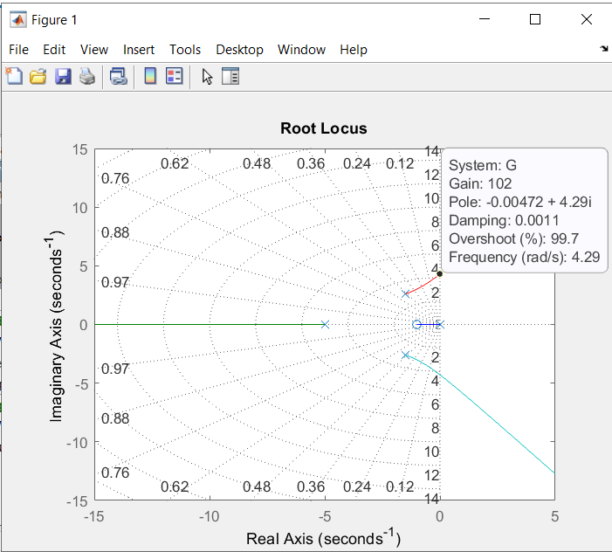

Figure 12: Root locus graph of the system with

### Gain K when ωn = 4:

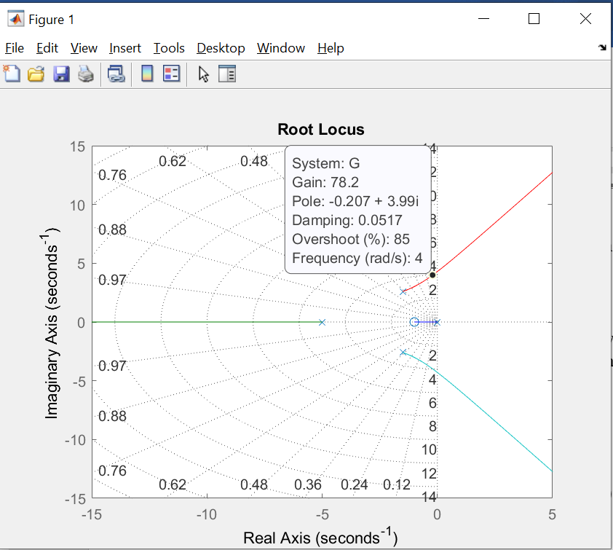

Figure 13: Root locus graph at ωn = 4

* K=78.2

### Gain K when damping ξ = 0.7

* Does not exist

### Gain K when overshoot σmax% = 25%

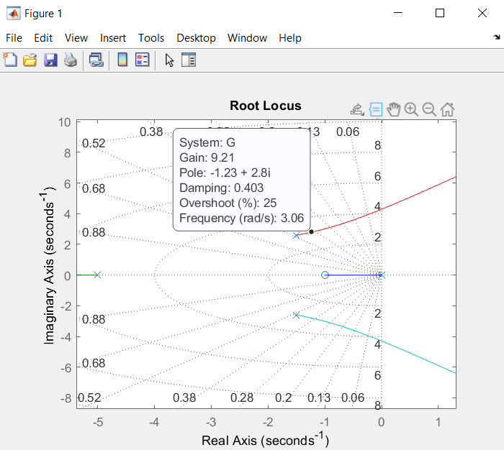

Figure 14: Root locus graph at σmax% = 25%

* K=9.21

### Gain K when txl =4s

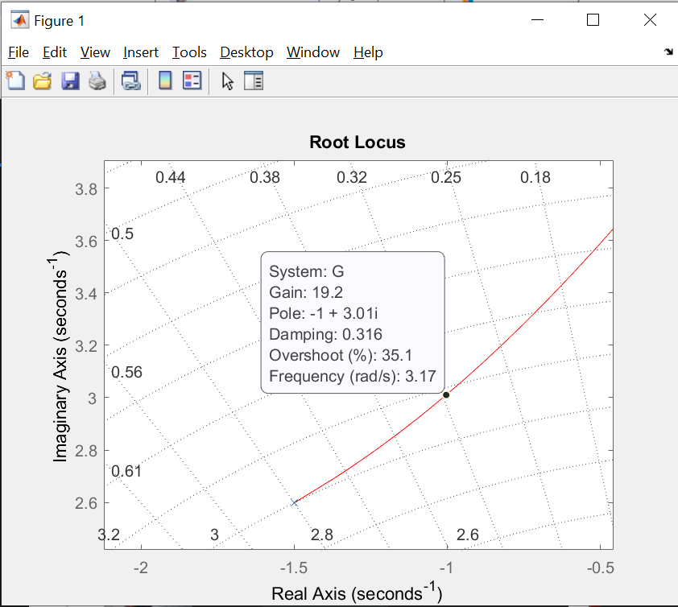

Figure 15: Root locus graph at txl = 4s

* K=19.2

### Bode diagram of the system with

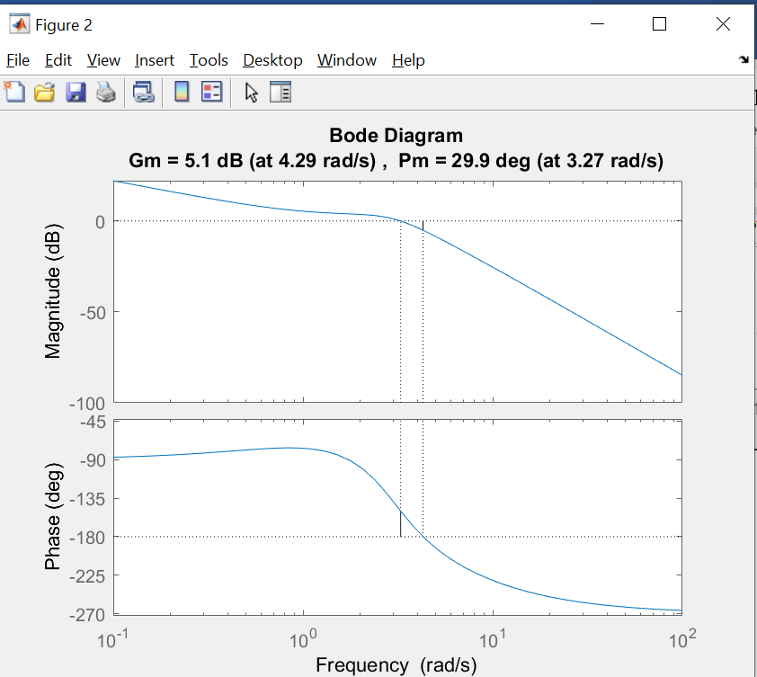

Figure 16: Bode diagram of the system with K=57

### Nyquist diagram of the system with

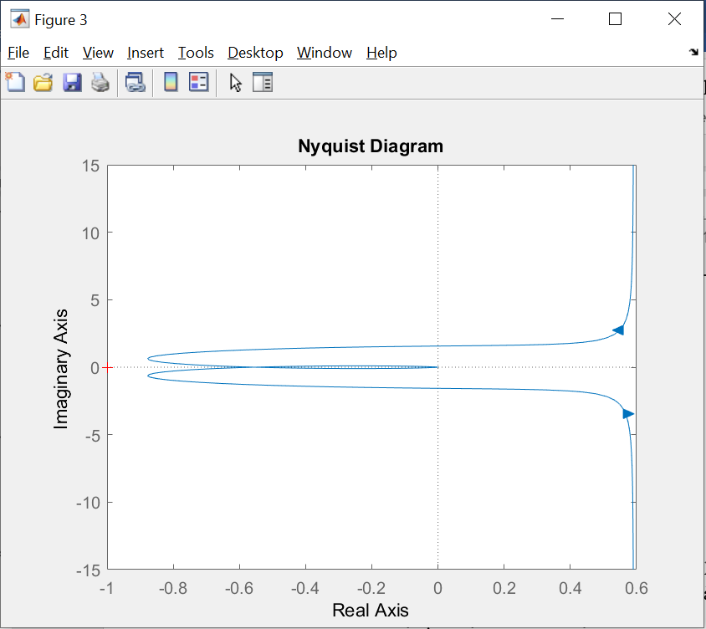

Figure 17: Nyquist diagram with K=57

# Open question

**Question 1:** Out of the three way, I think that using root locus will be the most useful out of the 2 because bode and nyquist diagram only provided us with information about the gain margin and phase margin while that using the root locus method’s we can quickly survey and find out with what gain K can be that the system will meet the system requirement like overshooting, damping or settling time,… etc.

**Question 2:** When we need to test if the system is stable or not.

**Question 3:** Both can find the gain margin and phase margin of the system